

***Entity Framework***

**Lab Guides**

|  |  |
| --- | --- |
| Document Code | 25e-BM/HR/HDCV/FSOFT |
| Version | 1.1 |
| Effective Date | 20/11/2012 |

**Hanoi, 07/2019**

RECORD OF CHANGES

|  |  |  |  |  |  |
| --- | --- | --- | --- | --- | --- |
| No | Effective Date | Change Description | Reason | Reviewer | Approver |
|  | 01/Oct/2018 | TuTB create new | Draft |  |  |
|  |  |  |  |  |  |
|  |  |  |  |  |  |
|  |  |  |  |  |  |
|  |  |  |  |  |  |
|  |  |  |  |  |  |
|  |  |  |  |  |  |
|  |  |  |  |  |  |
|  |  |  |  |  |  |
|  |  |  |  |  |  |

Contents

Lab: Change Tracking in Entity Framework 4

Objectives: 4

Prerequisites: 4

Problem Description: 4

Guidelines: 4

Step 1: Open Visual Studio and create a console project 4

Step 2: Check .net Framework version 4

Step 3: Add method DisplayTrackedEntities 4

Step 4: Print tracking information 5

Step 5: Run and check output 6

|  |  |
| --- | --- |
|  | **CODE: NEFW.S.L001**  **TYPE: SHORT**  **LOC: 100**  **DURATION: 30 MINUTES** |

# Lab: Change Tracking in Entity Framework

Objectives:

* Learn how Entity Framework tracks changes on entities during their life time..

Prerequisites:

* Download and installs Visual Studio (included .net Framework).

Problem Description:

* Entity Framework supports automatic change tracking of the loaded entities during the life-time of the context. The DbChangeTracker class gives you all the information about current entities being tracked by the context.
* Please note that every entity must have a key (primary key) property in order to be tracked by the context. Entity Framework will not add any entity in the conceptual model which does not have an EntityKey property.

Guidelines:

### Step 1: Open Visual Studio and create a console project

### Step 2: Check .net Framework version

Go to Project in the menu -> {project name} Properties.. - and make sure that the project's target framework is .NET Framework 4.5, as shown below.

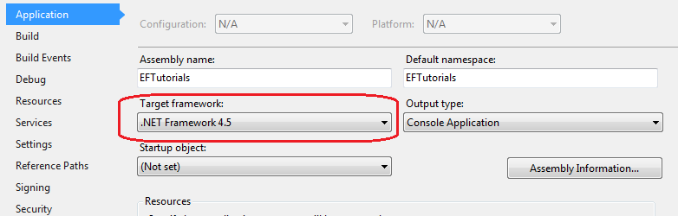

### Step 3: Add method DisplayTrackedEntities

private static void DisplayTrackedEntities(DbChangeTracker changeTracker)

{

Console.WriteLine("");

var entries = changeTracker.Entries();

foreach (var entry in entries)

{

Console.WriteLine("Entity Name: {0}", entry.Entity.GetType().FullName);

Console.WriteLine("Status: {0}", entry.State);

}

Console.WriteLine("");

Console.WriteLine("---------------------------------------");

}

### Step 4: Print tracking information

static void Main(string[] args)

{

using (var ctx = new SchoolDBEntities())

{

Console.WriteLine("Find Student");

var std1 = ctx.Students.Find(1);

Console.WriteLine("Context tracking changes of {0} entity.", ctx.ChangeTracker.Entries().Count());

DisplayTrackedEntities(ctx.ChangeTracker);

Console.WriteLine("Find Standard");

var standard = ctx.Standards.Find(1);

Console.WriteLine("Context tracking changes of {0} entities.", ctx.ChangeTracker.Entries().Count());

Console.WriteLine("");

Console.WriteLine("Editing Standard");

standard.StandardName = "Edited name";

DisplayTrackedEntities(ctx.ChangeTracker);

Teacher tchr = new Teacher() { TeacherName = "new teacher" };

Console.WriteLine("Adding New Teacher");

ctx.Teachers.Add(tchr);

Console.WriteLine("");

Console.WriteLine("Context tracking changes of {0} entities.", ctx.ChangeTracker.Entries().Count());

DisplayTrackedEntities(ctx.ChangeTracker);

Console.WriteLine("Remove Student");

Console.WriteLine("");

ctx.Students.Remove(std1);

DisplayTrackedEntities(ctx.ChangeTracker);

}

}

### Step 5: Run and check output

Find Student   
Context tracking changes of 1 entity.  
  
Entity Name: EFTutorials.Student  
Status: Unchanged  
  
---------------------------------------  
Find Standard  
Context tracking changes of 2 entities.  
  
Editing Standard  
  
Entity Name: EFTutorials.Standard  
Status: Modified  
Entity Name: EFTutorials.Student  
Status: Unchanged  
  
---------------------------------------  
Adding New Teacher  
  
Context tracking changes of 3 entities.  
  
Entity Name: EFTutorials.Teacher  
Status: Added  
Entity Name: EFTutorials.Standard  
Status: Modified  
Entity Name: EFTutorials.Student  
Status: Unchanged  
  
---------------------------------------  
Remove Student  
  
Entity Name: EFTutorials.Teacher  
Status: Added  
Entity Name: EFTutorials.Standard  
Status: Modified  
Entity Name: EFTutorials.Student  
Status: Deleted  
  
---------------------------------------